Math Reviewer
Factoring Methods
Common Greatest Monomial Factor (CMF):
- This technique involves factoring out the greatest common factor (GCF) from all terms in the polynomial. The GCF is the largest expression (monomial) that divides each term.
- Step 1: Identify the greatest common factor (GCF) of the coefficients and variables of each term.
- Step 2: Factor out this GCF from the entire expression.
- Step 3: Rewrite the polynomial as a product of the GCF and the remaining simplified terms.
Example: Factor ${6x}^{3}+{9x}^{2}$
- Step 1: Identify the GCF.
  - The GCF of the numbers 6 and 9 is 3.
  - The GCF of the variables $x^{3}$and $x^{2}$ is $x^{2}$ (since $x^{2}$ is the highest power of $x$ common to both terms).
  - Therefore, the GCF is ${3x}^{2}$
- Step 2: Factor out ${3x}^{2}$from both terms.
$${6x}^{3}+{9x}^{2}={3x}^{2}(2x+3)$$
Final Answer: The final factored form is ${3x}^{2}(2x+3)$

Difference of Two Squares (DOTS):
- This method is used when the expression is a difference (subtraction) between two perfect squares. The formula for factoring is: $a^{2}-b^{2}=\left(a-b\right)(a+b)$
- Step 1: Ensure that both terms are perfect squares (i.e., they can be written as squares of some numbers or variables).
- Step 2: Apply the formula $a^{2}-b^{2}=(a-b)(a+b)$ to factor.
Example: Factor $x^{2}-9$
- Step 1: Recognize that $x^{2}$ is a perfect square ${(x}^{2})$ and $9$ is a perfect square $(3^{2})$
- Step 2: Apply the formula:
$$x^{2}-9=(x-3)(x+3)$$
- Final Answer: $(x-3)(x+3)$

Sum of Two Cubes (SOTC):
- This method is used when you have a sum of two perfect cubes. The formula is:
$$a^{3}+b^{3}=\left(a+b\right)\left(a^{2}-ab+b^{2}\right)$$
- Step 1: Identify that both terms are cubes.
- Step 2: Use the formula for the sum of cubes.
Example: Factor $x^{3}+8$
- Step 1: Recognize that $x^{3}$ is a cube $(x^{3})$ and $8$ is a cube $(2^{3})$
- Step 2: Apply the formula:
$$x^{3}+8=(x+2)({\left(x\right)}^{2}-\left(x\right)\left(2\right)+{\left(2\right)}^{2})$$
- Simplify: $x^{3}+8=(x+2)(x^{2}-2x+4)$
- Final Answer: $(x+2)(x^{2}-2x+4)$

Difference of Two Squares (DOTC):
- This method is used when you have a difference of two perfect cubes. The formula is:
$$a^{3}-b^{3}=\left(a-b\right)\left(a^{2}+ab+b^{2}\right)$$
- Step 1: Identify that both terms are cubes.
- Step 2: Use the formula for the difference of cubes.
Example: Factor $x^{3}-8$
- Step 1: Recognize that $x^{3}$ is a cube $(x^{3})$ and $8$ is a cube $(2^{3})$
- Step 2: Apply the formula:
$$x^{3}-8=(x-2)({\left(x\right)}^{2}+\left(x\right)\left(2\right)+{\left(2\right)}^{2})$$
- Simplify: $x^{3}+8=(x+2)(x^{2}-2x+4)$
Final Answer: $(x-2)(x^{2}+2x+4)$

Perfect Square Trinomial (PST):
- Step 1: Check if the first and last terms are perfect squares.
- Step 2: Confirm if the middle term is $2ab$ (where $a$ and $b$ are the square roots of the first and last terms).
- Step 3: Write the trinomial as ${(a+b)}^{2} or {(a-b)}^{2}$m
Example: $x^{2}+6x+9$
- Step 1: Recognize that $x^{2}$ and $9$ are perfect squares ${(x}^{2} and 3^{2})$
- Step 2: Check th middle term. $6x$ is twice the product of $x$ and $3\left(2×x×3+6x\right)$
- Step 3: Factor as ${(x+3)}^{2}$
- Final Answer: ${(x+3)}^{2}$

Trial and Error Method (TAEM):
- This method involves trying different factor pairs for a trinomial until you find the right pair that works.
- Step 1: Multiply the first and last coefficients of the trinomial.
- Step 2: Find factor pairs of this product that sum to the middle coefficient.
- Step 3: Test these factor pairs to see which ones give you the original trinomial when expanded.
Example: ${2x}^{2}+5x+3$
- Step 1: Multiply the first and last coefficients: $2×3+6$
- Step 2: Find fact pairs of 6. The factor pairs are $(1, 6)$ and $(2, 3)$
- Step 3: Test
$$(2x+3)(x+1)$$
- Step 4: Multiply
$$\left(2x+3\right)\left(x+1\right)={2x}^{2}+2x+3x+3={2x}^{2}+5x+3$$
- Final Answer: $\left(2x+3\right)\left(x+1\right)$

AC Method:
- This method splits the middle term of a trinomial after multiplying the first and last coefficients.
- Step 1: Multiply the leading coefficient (A) by the constant term (C).
- Step 2: Find two numbers that multiply to this product and add to the middle coefficient (B).
- Step 3: Split the middle term into two terms, factor each group, and finish by factoring by grouping.
Example: ${6x}^{2}+11x+4$
- Step 1: Multiply $6×4=24$
- Step 2: Find two numbers that multiply to $24$and add to $11.$ These numbers are $8$ and $3$.
- Step 3: Rewrite the middle term:
$${6x}^{2}+11x+4={(6x}^{2}+8x)+(3x+4)$$
- Step 4: $\left({6x}^{2}+8x\right)+\left(3x+4\right)=2x\left(3x+4\right)+1(3x+4)$
- Final Answer: $(2x+1)(3x+4)$
Groupings:
- This method involves grouping terms in pairs and factoring out common factors.
- Step 1: Group the terms in pairs.
- Step 2: Factor out the greatest common factor (GCF) from each pair.
- Step 3: Factor out the common binomial factor.
Example: $x^{2}+{3x}^{2}+2x+6$
- Step 1: Group terms: ${(x}^{2}+{3x}^{2})+(2x+6)$
- Step 2: Factor each group
$$x^{2}\left(x+3\right)+2(x+3)$$
- Step 3: Factor out the common binomial $(x+3)$
$$(x+3)(x^{2}+2)$$
- Final Answer: $(x+3)(x^{2}+2)$
Determining Factors Whether They Are Positive or Negative:
- $+ +$: Both Positive Factors.
- $- -$: Negative Largest Number, positive smallest number.
- $+ -$: Positive largest number, negative smallest number.
- $- +$: Negative both numbers.

Quadratic Equation
Quadratic Equation:
- Quadratic Equation - A quadratic equation is a type of polynomial equation of degree 2, which means the highest exponent of the variable (usually x) is 2.
Formula:  $$ax^{2}+bx+c=0$$ | Definition:  $$a, b, and c=real constants$$  $$x=unknown variables$$  $$(if a ≠0, the equation becomes linear)$$

Table of Values: First Step
- To graph a quadratic, you can choose several values of x, substitute them into the equation, and compute y.
- Each pair (x, y) forms a point on the graph.
- It’s useful to choose values of x around the vertex (h, k) because the parabola is symmetric about the vertical line $x=h$.

Complete Solution for Corresponding Y-values: Second Step
- Substitute it into the quadratic expression $y=ax2+bx+cy = ax^2 + bx + cy=ax2+bx+c$.
- Perform squaring, multiplication, and addition step by step.
- The final result is the y-value corresponding to that x.

Graph of a Quadratic Function:
- When the points from the table of values are plotted, they form a parabola.
- Shape:
- If a > 0, the parabola opens upward (U-shaped).
- If a < 0, it opens downward (∩-shaped).
- Width:
- Larger ∣a∣|a|∣a∣ makes the parabola narrower.
- Smaller ∣a∣|a|∣a∣ makes it wider.
- Symmetry: Always symmetric about the line $x=h$ (the axis of symmetry).

Transforming to Vertex Form:
- The standard form of a quadratic is:
$$y=ax^{2}+bx+c$$
- The vertex (h, k) form is:
$$y=a{\left(x-h\right)}^{2}+k$$
- How to Find H: $h=-\frac{b}{2a}$ (This gives the axis symmetry).
- How to Find k: Once you have h, plug it to the formula of $y=ax^{2}+bx+c$ whereas $x=h$

Computing X and Y Intercept:
- Y-Intercept – Use the formula $y=ax^{2}+bx+c$whereas $x=0$ and only getting the number from $c$. Meaning the end product looks like $\left(0, c\right)$
- X-Intercept – Use the formula $x=\frac{-b\sqrt{b^{2}-4ax }}{2a}$ and plug in the values.

Observations of Value of a, h, and k:
- Observation of A Values:
- If a > 0, the parabola opens upward (U-shaped).
- If a < 0, the parabola opens downward (∩-shaped).
- Observation of H Values:
- If h > 0, parabola shifts right.
- If h < 0, parabola shifts left.
- Observations of K Values:
- If k > 0, parabola is translated upward.
- If k < 0, parabola is translated downward.

Example of Quadratic Equation

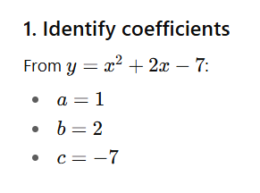 | 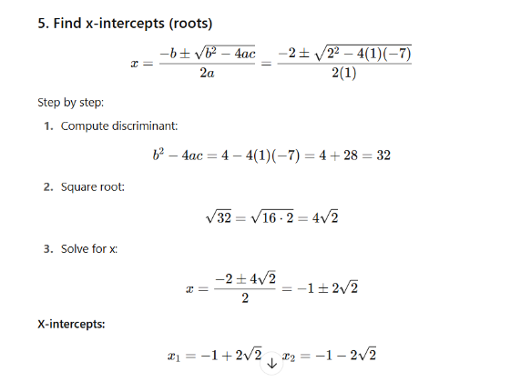
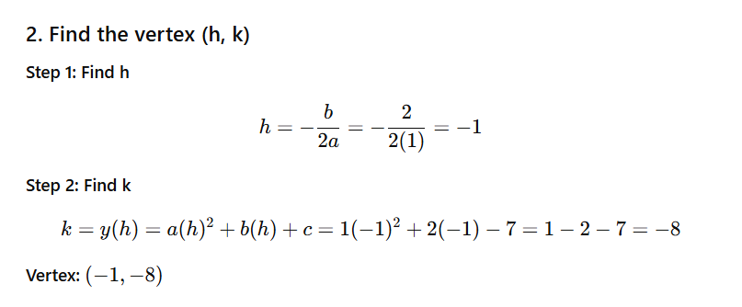 | 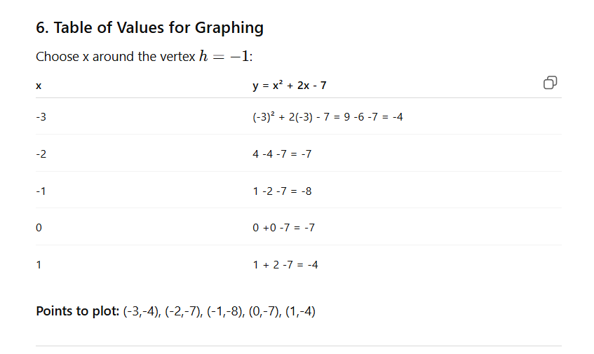
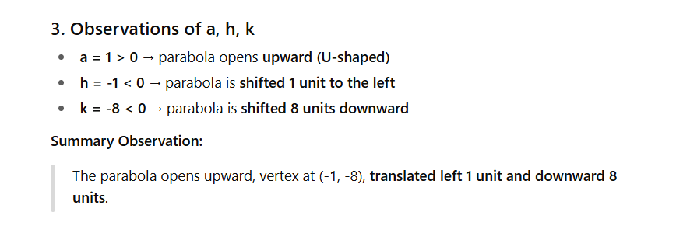 | 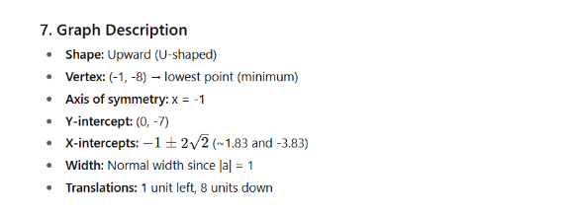
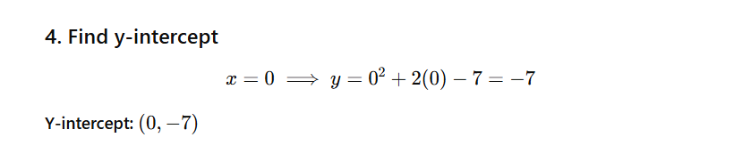

Finding the Roots of Quadratic Equations:
Quadratic Formula:  - For any quadratic equation $ax^{2}+bx+c=0$, the roots can be found using: | Formula:  $$x=\frac{-b±\sqrt{b^{2}-4ac}}{2a}$$

